**Training Material for repliCATS Qualitative Analysts**

### Contents:

Overview of the repliCATS project: 1

Roles of Assistant Qualitative Analysts within the Reasoning Analysis Team 1

Overview of the textual-analysis process 2

Guidelines for Coding: 3

Supplementary Material: 5

## Overview of the repliCATS project:

The repliCATS project is undertaken by the Metamelb research group, sitting across the School of Biosciences and the School of Historical and Philosophical Studies at the University of Melbourne (more can be found [here](https://www.metamelb.org/)). Within repliCATS, qualitative analysts are mostly found within the Reasoning Analysis Team (more info can be found [here](https://replicats.research.unimelb.edu.au/#tab42)).

## Roles of Assistant Qualitative Analysts within the Reasoning Analysis Team

The role of analysts is to help code short-form text responses collected on an online platform and interview to allow qualitative analysis of these responses. A copy of the platform questions and/or interview questions will be supplied as supplementary material within NVivo.

Analysts will code the textual responses using an established guidelines and codebook within an NVivo project (provided within the NVivo Project). If additional NVivo training is required, please ask. In between meetings, questions about coding or the process more generally can be sent to [martin.bush@unimelb.edu.au](mailto:martin.bush@unimelb.edu.au) or eden.smith@unimelb.edu.au

Analysts will be working within the Reasoning Analysis Team – the team responsible for the analysis of textual data collected during the repliCATS project. Given the quantity of data gathered, different aspects of the analysis process have been shared to distribute the workload. To this end, the following roles have been specified:

* *Merge-manager*: one person responsible for setting up the NVivo projects, leading the development of the codebook, managing the merging of sub-projects, supervising research assistants, and documenting the research process.
* *Core-analysts:* in addition to the merge-manager, two core analysts from the Reasoning Analysis Team contributed to the development of the codebook. In addition, each of the core-analysts were responsible for managing the analysis decisions related to the research questions they were leading.
* *Support-analysts:* people from the broader repliCATS team who coded sections of the data following existing codebooks. This included either analysing sets of data during the calibration process (where they provide an additional point-of-view to help assess inter-coder reliability of the categories) and/or supporting one or more of the core-analysts in indexing the sets of data relevant to their research questions.
* *Naïve-analysts:* research assistants who had not been involved in the development or calibration of the codebook and provided naïve coding for sections of data that could be compared to the coding of analysts for calculating a final ICR for reporting the inter-subjective reliability of our codebook for guiding interpretive analysis of this set of textual data.[1]

Support analysts and research assistants will be working under the direction of Martin Bush, Eden Smith, and/or Fallon Mody (depending on the project).

## Overview of the textual-analysis process

*Prior to undertaking coding, analysts will:*

1. Attend a training meeting (or, for support analysts, meet with one of the core analysts to receive initial guidance on the process)
2. Attend a ‘repliCATS at home’ meeting (if possible).
3. Receive training materials and an NVivo training project (with which you should familiarise yourself with the coding guidelines, codebook, and NVivo project structure).
4. Practice coding the training data set
5. Meet with the core-analysts to discuss the practice coding. This will enable calibration between each of the analysts.
6. Repeat steps 4-6 if needed.

*For each round of coding, analysts will receive a email with instructions on:*

1. Finding the NVivo project (this should be downloaded and saved with your initials at the end of the file name).
2. The dataset(s), or subsets of data (e.g., the selection of claims) that you’ve been allocated to complete within a given time-frame. *See guidelines below on how to filter datasets by claim.*
3. Code text to relevant NODES following the instructions and codebook. *See guidelines below and remember to save your work frequently*
4. Upon request, send the most recent copy of their project to the merge-manager.   
   Unless otherwise specified, the analyst should then wait for a new, updated NVivo file to be sent back before doing any more coding.

*After each round of coding, analysts may be asked to:*

1. Share their notes with the other analysts.
2. Meet with all coders to discuss and resolve any ambiguities or uncertainties that emerged during coding.

**Caution!**

* never add sources or cases (adding nodes is permissible under certain conditions, see above).
* never delete or change the names of nodes, cases, or classifications
* never delete sources or transcripts
* any additions should be documented and justified.

## Guidelines for Coding:

### The Codebook:

The codebook provides the set of categories for indexing textual-data collected during the repliCATS project. This includes analytic categories and administrative categories determined based on earlier rounds of textual analysis from equivalent sets of textual-sets.

‘Coding’ involves indexing ‘text-units’ to one or more categories (‘nodes’) within the codebook provided. Unless specified otherwise, a text-unit is the entire response provided to one of the questions asked of a participant (this ranges in length from a few words to several sentences).

Each of the codebook categories is listed as a NODE within NVivo. As outlined in the codebook, the structure of nodes includes three-layers[2]

* Layer 1 nodes: **Do not apply these nodes** (these are SECTION dividers for sorting)
* Layer 2 nodes: **apply as many level 2 nodes as are relevant to each text-unit.**   
  If considering between multiple nodes, code for ALL nodes considered (rather than choosing between them). If any of the nodes conflict, also code for the ‘review coding’ node and make a note of the conflict.
* Layer 3 nodes: these are **optional sub-categories.** You are not expected to use these unless specifically required (they are for additional rounds of analysis). If you choose to use these nodes, please inform the *merge-manager* when you return the file.

Application of relevant nodes to text-units should align with the specific guidelines provided in the codebook. In addition, remember the following:

* There are multiple ways to ‘code’ in NVivo, with differences between Windows and Mac versions. Use whichever you are most confident with.[3]
* **Highlight ALL the text in a text-unit and then apply** **all relevant nodes**
* Determining the relevance of nodes should be based on a context-sensitive interpretation of the text. **Avoid coding based on the mere presence of a term in the text** - always consider the use of that term in the context of the text-unit as well as which question the text-unit is a response to, what else the participant has said, and so forth.
* Applications of relevant nodes should be generous: **err towards the liberal application of multiple nodes for each text-unit, as outlined in the codebook.**
* Unless specified otherwise, **nodes should be used for both positive and negative instances of the category**. For example, for the node ‘importance of claim’, you would use it to code instances where the participant mentioned that the claim was ‘worthwhile’ as well for when a participant mentioned that the claim was ‘trivial’. Exceptions to this are denoted by the inclusion of a + or a - sign at the end of the node name. A + sign indicates that the node is only to be used for the presence of the feature described by the node name, a - sign that the node is only to be used for the absence of the feature.
* The goal is to maintain consistency between analysts in the application of nodes to text-units, especially for analytic categories (most nodes in Sections 1-5). The administrative nodes (Section 6) are expected to be used idiosyncratically.
* If you are uncertain of a term of type of practice discussed in the text code for ‘statement unclear’ and ‘review codes in this text’ and make a note of the term/practice. Please record notes into the MEMO with your initials on it. At the start of each note, include the information in the ‘Unique id’ column of the J&C File. If you record notes in any additional way, please inform the *merge manager* when you return the file.

**To avoid overthinking the meaning of a given text-unit, remember:**

* Focus on identifying what elements of the claim/article/study were considered by the participant when estimating how likely given research claims would replicate and/or mentioned in relation to how well they understood of the article.
* Focus also on the experience of the participant in answering these claims on the online platform, either in a face to face workshop or remotely.
* We cannot assume participants have expertise in the task they are being asked to do.
* We cannot assume that participants have availed themselves of the information we’ve provided, and even if they have we cannot assume they will remember it. (Participants will have completed demographics).
* We cannot assume that participants will be internally consistent in how they are using terms, or that they will understand terms in the way that the repliCATS project does.
* If you have difficulty understanding the meaning of a statement or term, code for ‘statement unclear’ and write a note about the term that requires clarification.
* If you are uncertain about your interpretation of a statement or term, code for all nodes relevant to your best interpretation then also code for ‘review coding’ (writing a note to record your uncertainty).
* There is no need to familiarise yourself with specific disciplinary practices discussed or read the papers or abstract for the relevant claim.

### Additional guidance for in-platform textual responses:

The application of nodes depends on the overall context of the participant experience on the online platform and the specific contexts of the in-platform questions. Of the five questions the participants were asked on the platform, three allowed for a textual response:

* Question 1: How well do you understand this claim?
* Question 3: What is the probability that direct replications of this study would find a statistically significant effect in the same direction as the original claim (0-100%)? 0 means that you think that a direct replication would never succeed, even by chance. 100 means that you think that a direct replication would never fail, even by chance.
* Question 4: Considering the major factors that influenced your thinking in making these judgements, please describe any important aspects that you have not covered above.

Each question was asked twice: before discussion (round 1) and after an opportunity for discussion (round 2) and these each provides a slightly different context for coding:

* For question 1, assume that participant responses may be broader than that asked for in the question (about comprehension). Assume that a restatement of the claim reflects a participant’s understanding of the claim unless stated otherwise - code these as ‘restatement of claim’.
* For question 3, assume that any text provided constitutes reasoning of participants about question three (direct replication). If the text clearly does not provide reasoning but restates a judgement, then code for ‘statements with no reasons provided’.
* For question 4, assume that participant responses are not intended as specific to any question. If the meaning and context of a statement is not able to be determined easily (from reading the text in context of the claim) code for ‘statement unclear’.

## Supplementary Material:

### NVivo on Windows: Sorting & Managing data

#### FIND subsets of data in NVivo

Within the NVivo project, navigate to ‘Data’ 🡪 ‘Files’

Select the relevant DataSet. For example, select *‘DataSet1_platformJ&C’:*

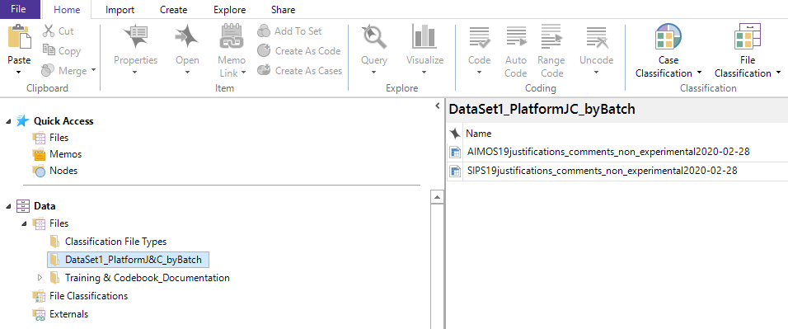

Within this folder, select the relevant File. For example, if allocated to analyse the SIPS dataset, select ‘SIPS19justifications_comments_non_experimental2020-02-28’: For any of the ‘justification_comments’ files, this will open a spreadsheet that looks something like this.

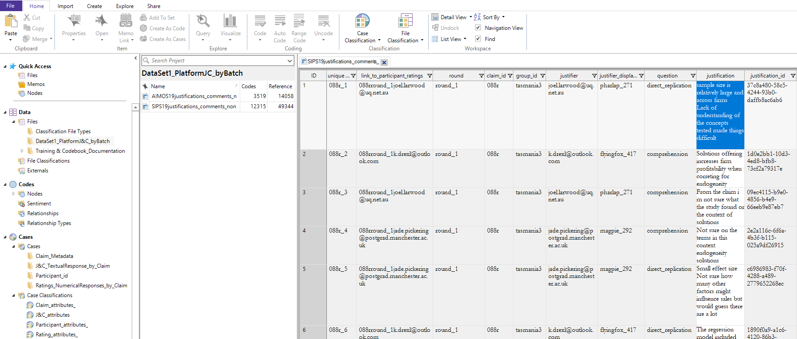

The spreadsheets are large and to make them manageable (and find the data you’ve been allocated), use the filter and sort tools to help you find and contextualise the data.

#### FILTER to find a given claim_id:

* In the spreadsheet, click on the ‘filter’ symbol in the ‘claim_id’ column. In the pop-up box, select ‘show’ equal to the value of whatever claim id you are going to code next. In this example, this filter reduces the size of the visible file to from 12337 responses to 31.
* 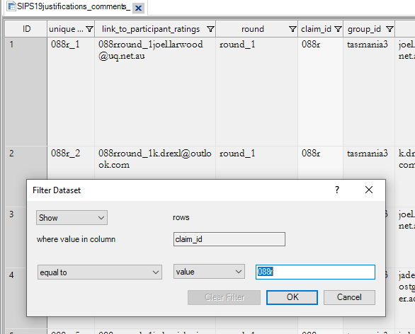

#### SORT the data for context:

* Click anywhere in the spreadsheet. In the ‘Dataset’ tab within the ribbon at the top of the screen, select ‘Sort & Filter’ and then select ‘Custom’ from the drop-down options. One option is to sort by ‘round’, then ‘question’, then ‘participant display name’. This will give you all the responses to each question, per round, together which can help keep that question in mind when coding and help to highlight any changes from round-1 to round-2 for participants. (The last option will keep any comments close to the justification they are associated with.)
* 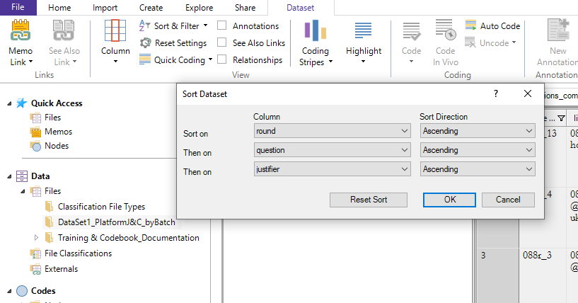

#### Options to VIEW the data

* The table view can be quicker if you’re used to it, but unwieldy and may lead to missing text in the ‘comments’ section. To avoid this, you can ‘hide’ columns by right-clicking, selecting ‘column’ and choosing ‘hide column’ from the drop-down menu.
* The ‘form view’ requires ‘clicking through’ for each line in the table but is easier to use and a lot less likely to overlook any of the (relatively rare) comments.

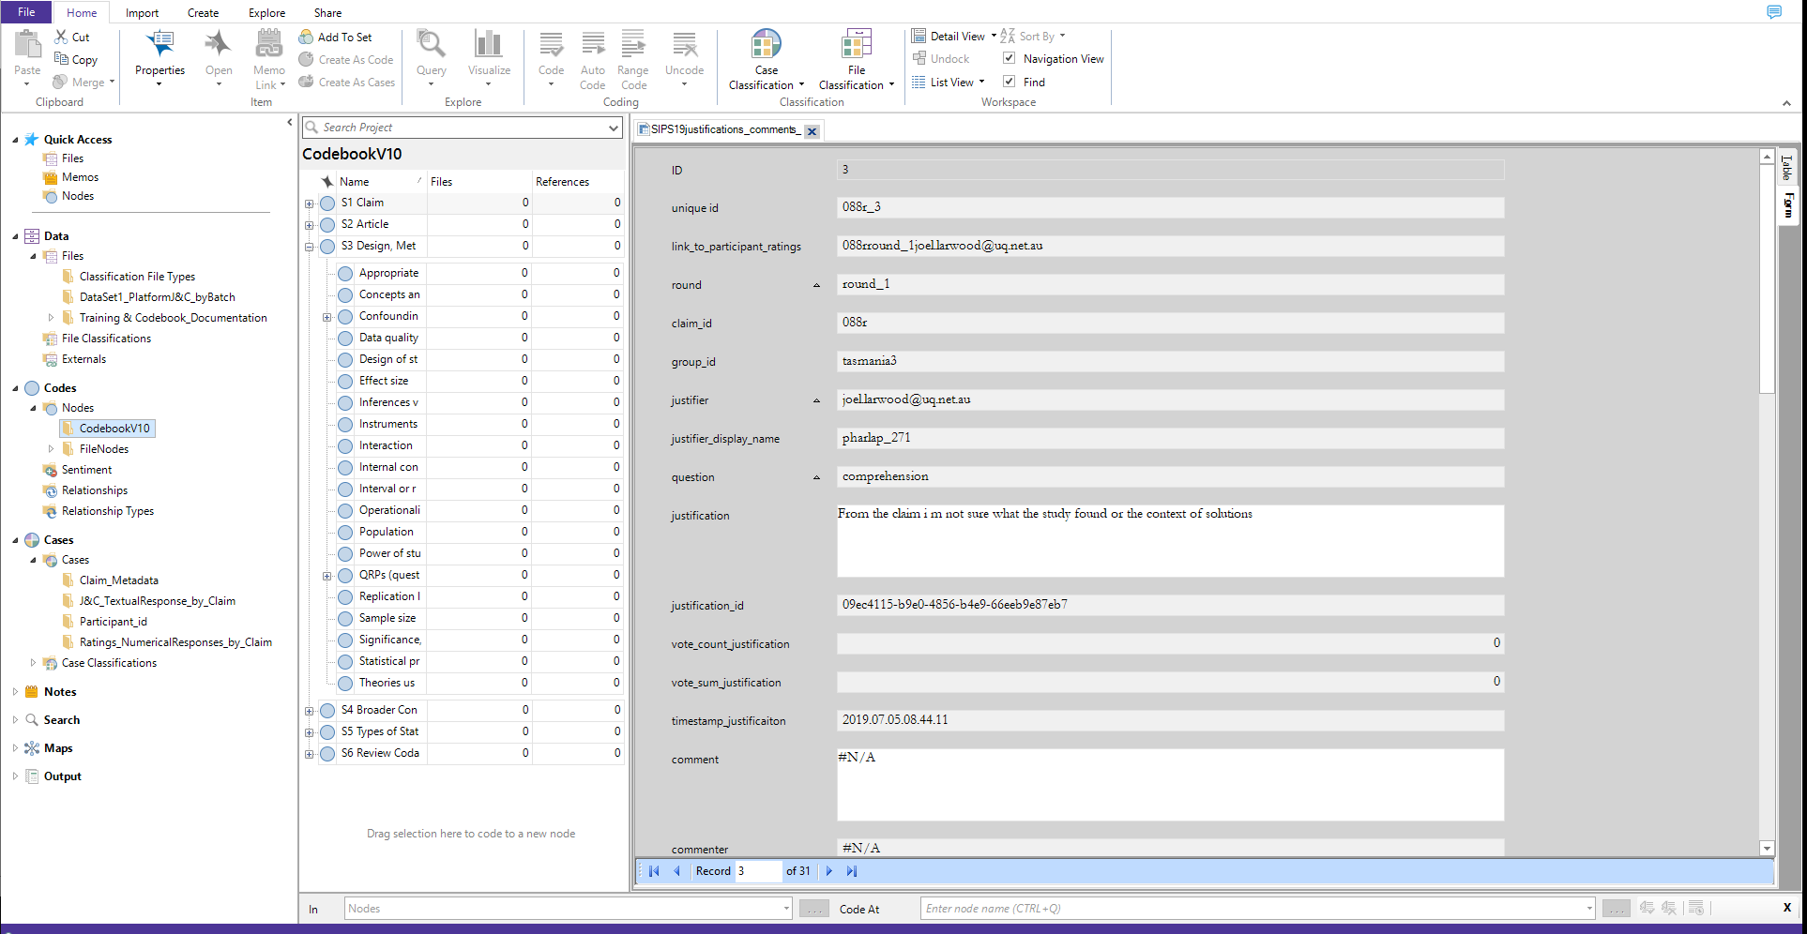

### NVivo on Mac OSX: Sorting & Managing data

#### Instructions for MacOSX are similar to those in Windows. However, note that not all options within the Windows version of NVivo can be found in the Mac version. For example, ‘Form View’ is not available.

#### FIND subsets of data in NVivo

Within the NVivo project, navigate to ‘Data’ → ‘Files’

Select the relevant DataSet. For example, select *‘DataSet1_platformJ&C’:*

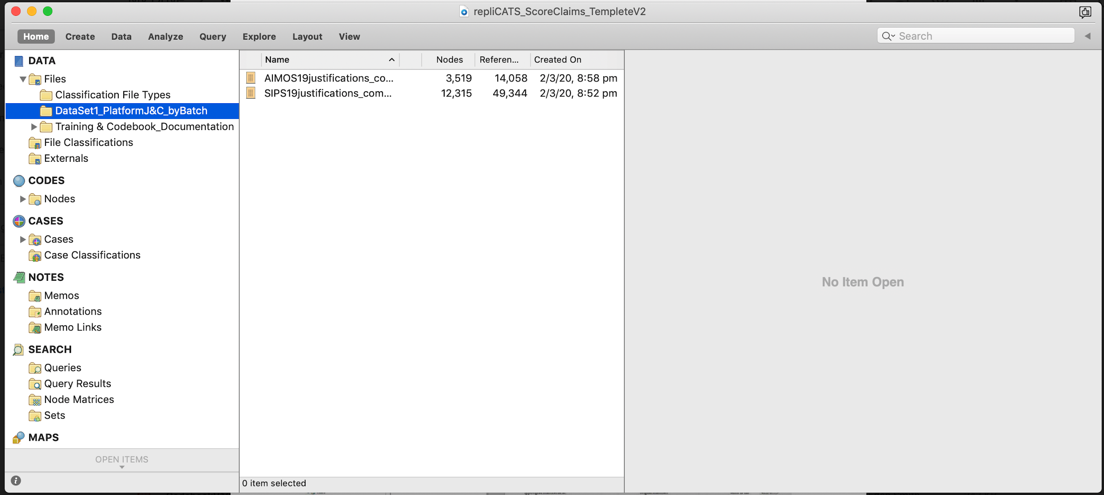

Within this folder, select the relevant File. For example, if allocated to analyse the SIPS dataset, select ‘SIPS19justifications_comments_non_experimental2020-02-28’: For any of the ‘justification_comments’ files, this will open a spreadsheet that looks something like this.

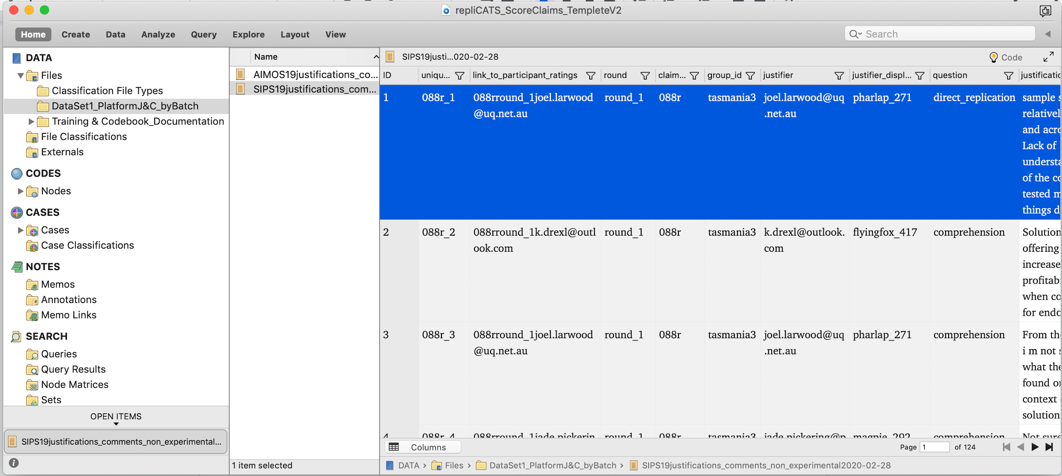

The spreadsheets are large and to make them manageable (and find the data you’ve been allocated), use the filter and sort tools to help you find and contextualise the data.

#### FILTER to find a given claim_id:

In the spreadsheet, click on the ‘filter’ symbol in the ‘claim_id’ column. In the pop-up box, select ‘show’ equal to the value of whatever claim id you are going to code next. In this example, this filter reduces the size of the visible file to from 12337 responses to 31.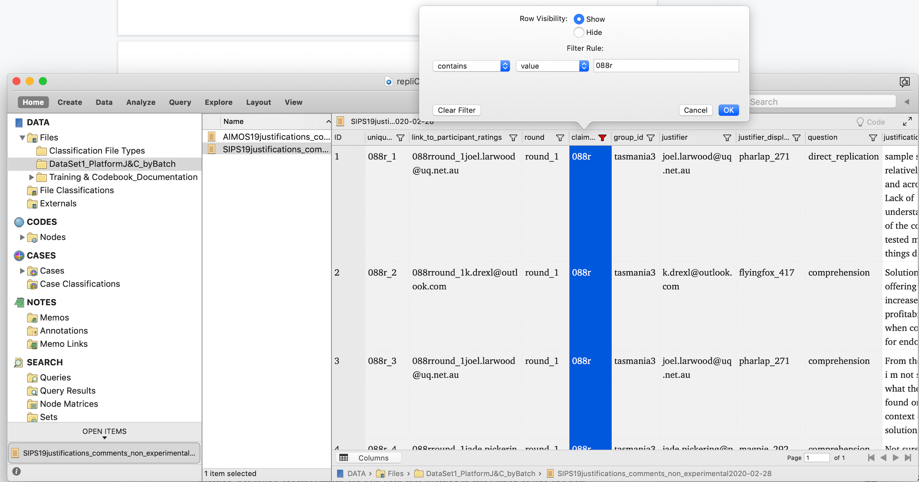

#### 

#### SORT the data for context:

Click anywhere in the spreadsheet. In the Layout tab at the top of the screen, select ‘Sort & Filter’ and then select ‘Custom’ from the drop-down options. One option is to sort by ‘round’, then ‘question’, then ‘participant display name’. This will give you all the responses to each question, per round, together which can help keep that question in mind when coding and help to highlight any changes from round-1 to round-2 for participants. (The last option will keep any comments close to the justification they are associated with.)

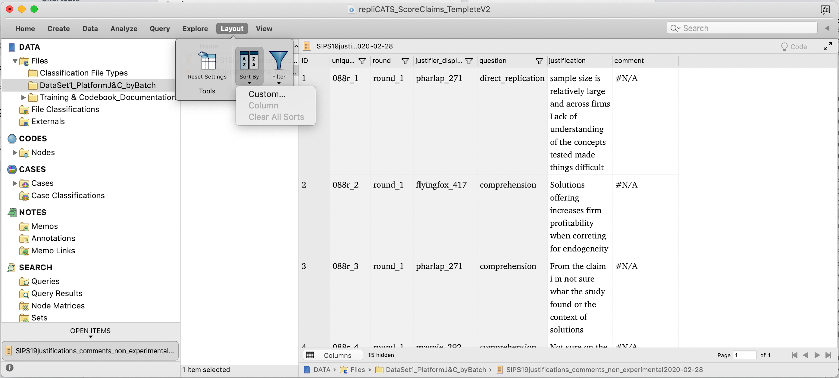

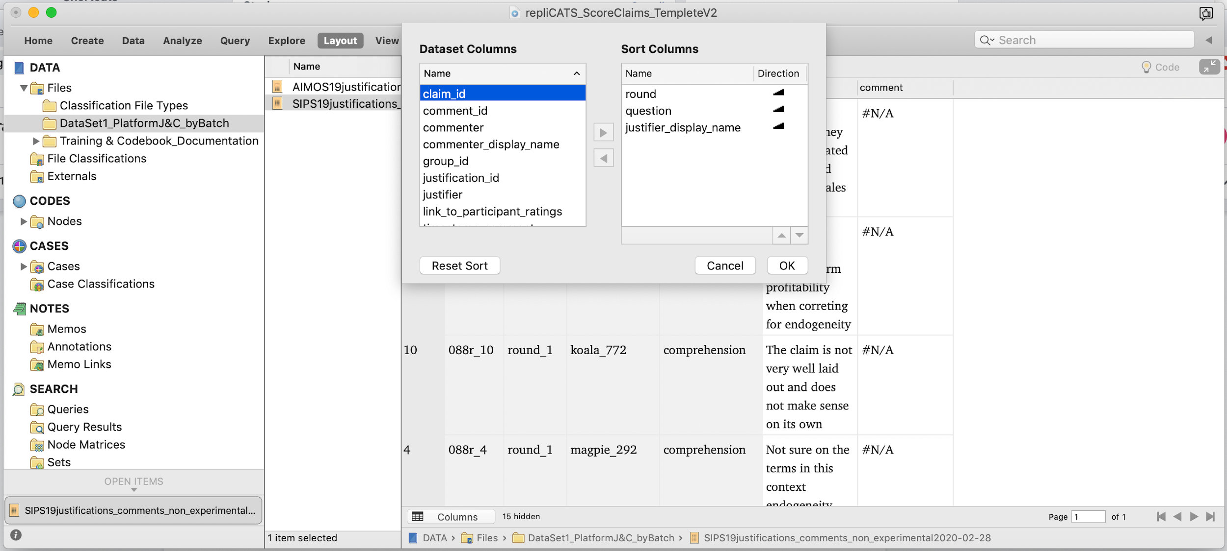

#### 

#### Options to VIEW the data

* You can simplify the table view by ‘hiding’ unnecessary columns with the pop-up menu.

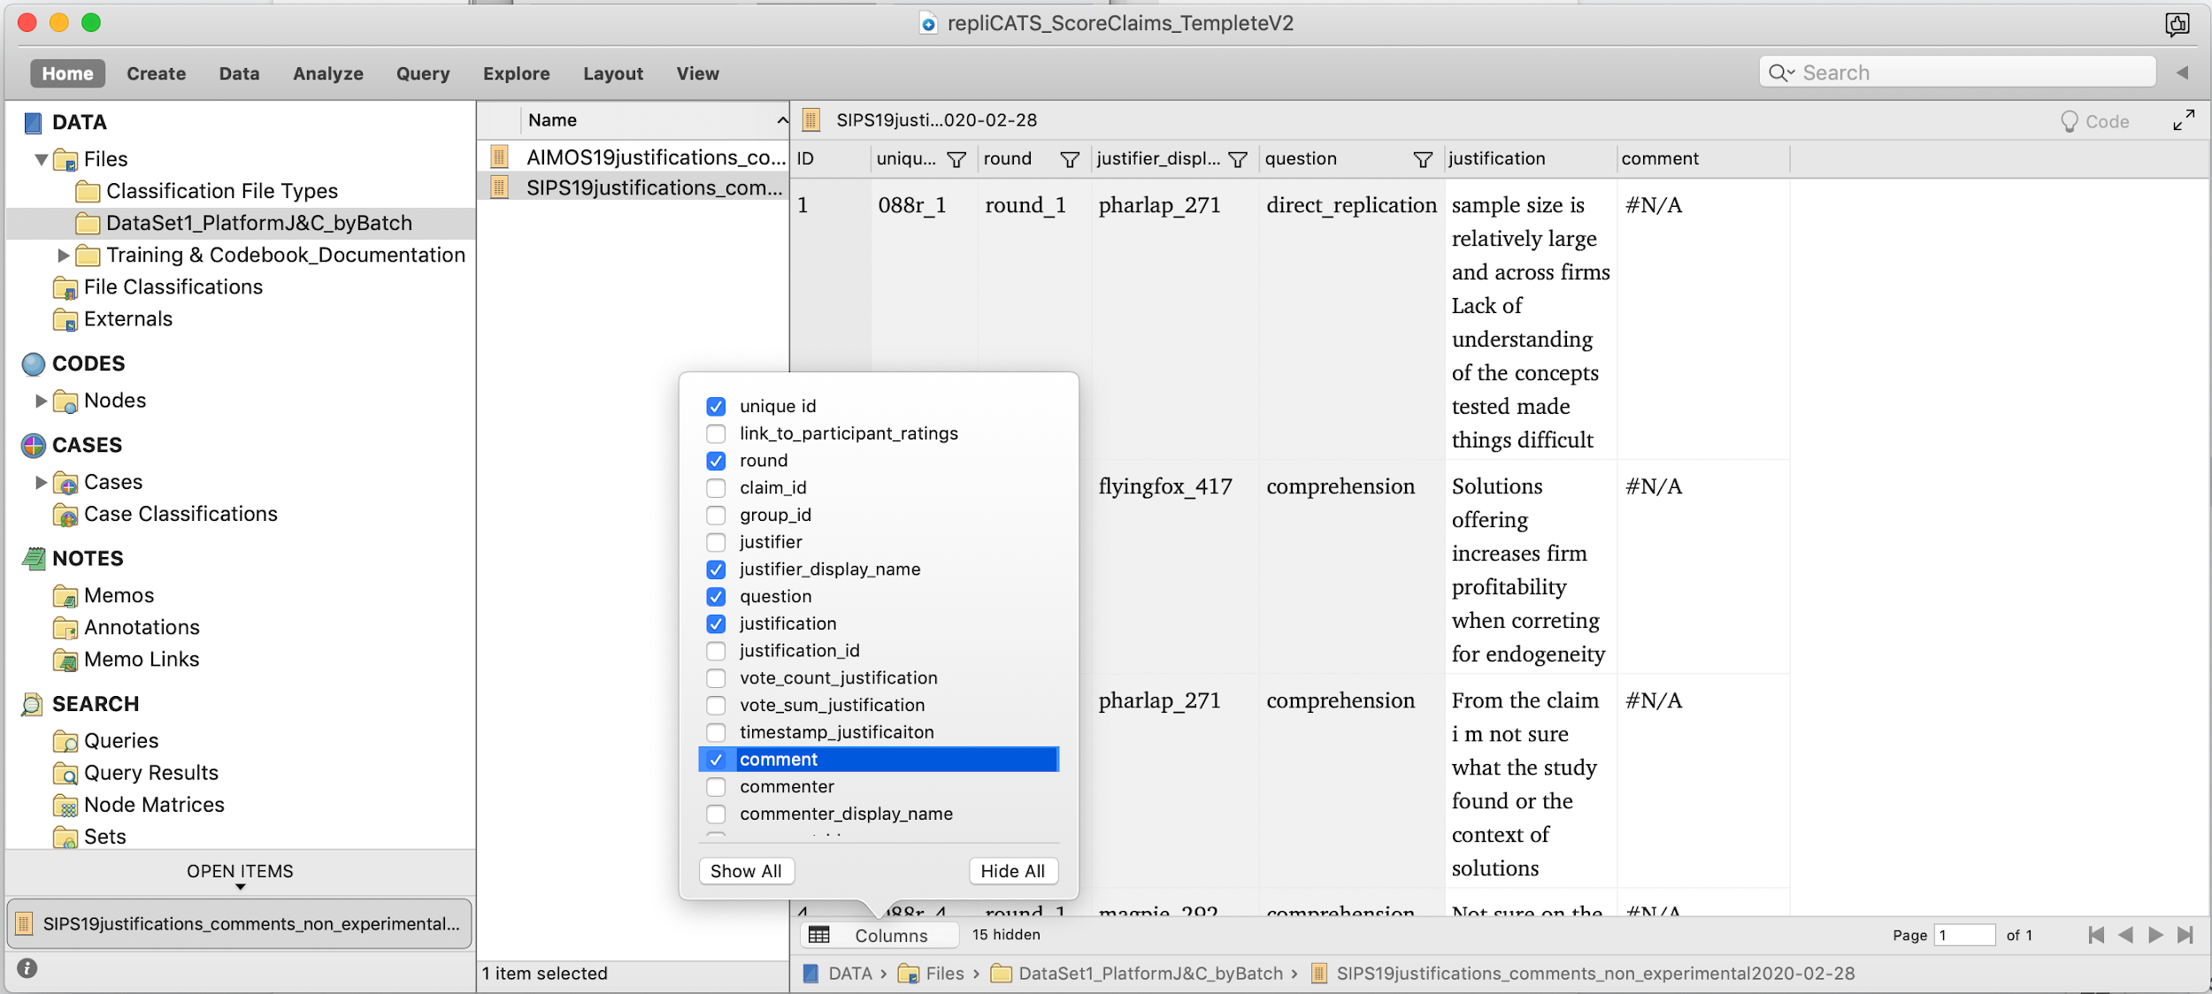

#### Coding with NODES

The are several approached to this, use what works best for you. For example, the coding-bar select ‘Node’ on the left and then search in then use the ‘Code at’ section and select from the drop-down options filtered by the search. Then hit ‘enter’ or select the green tick to the right of the search box.

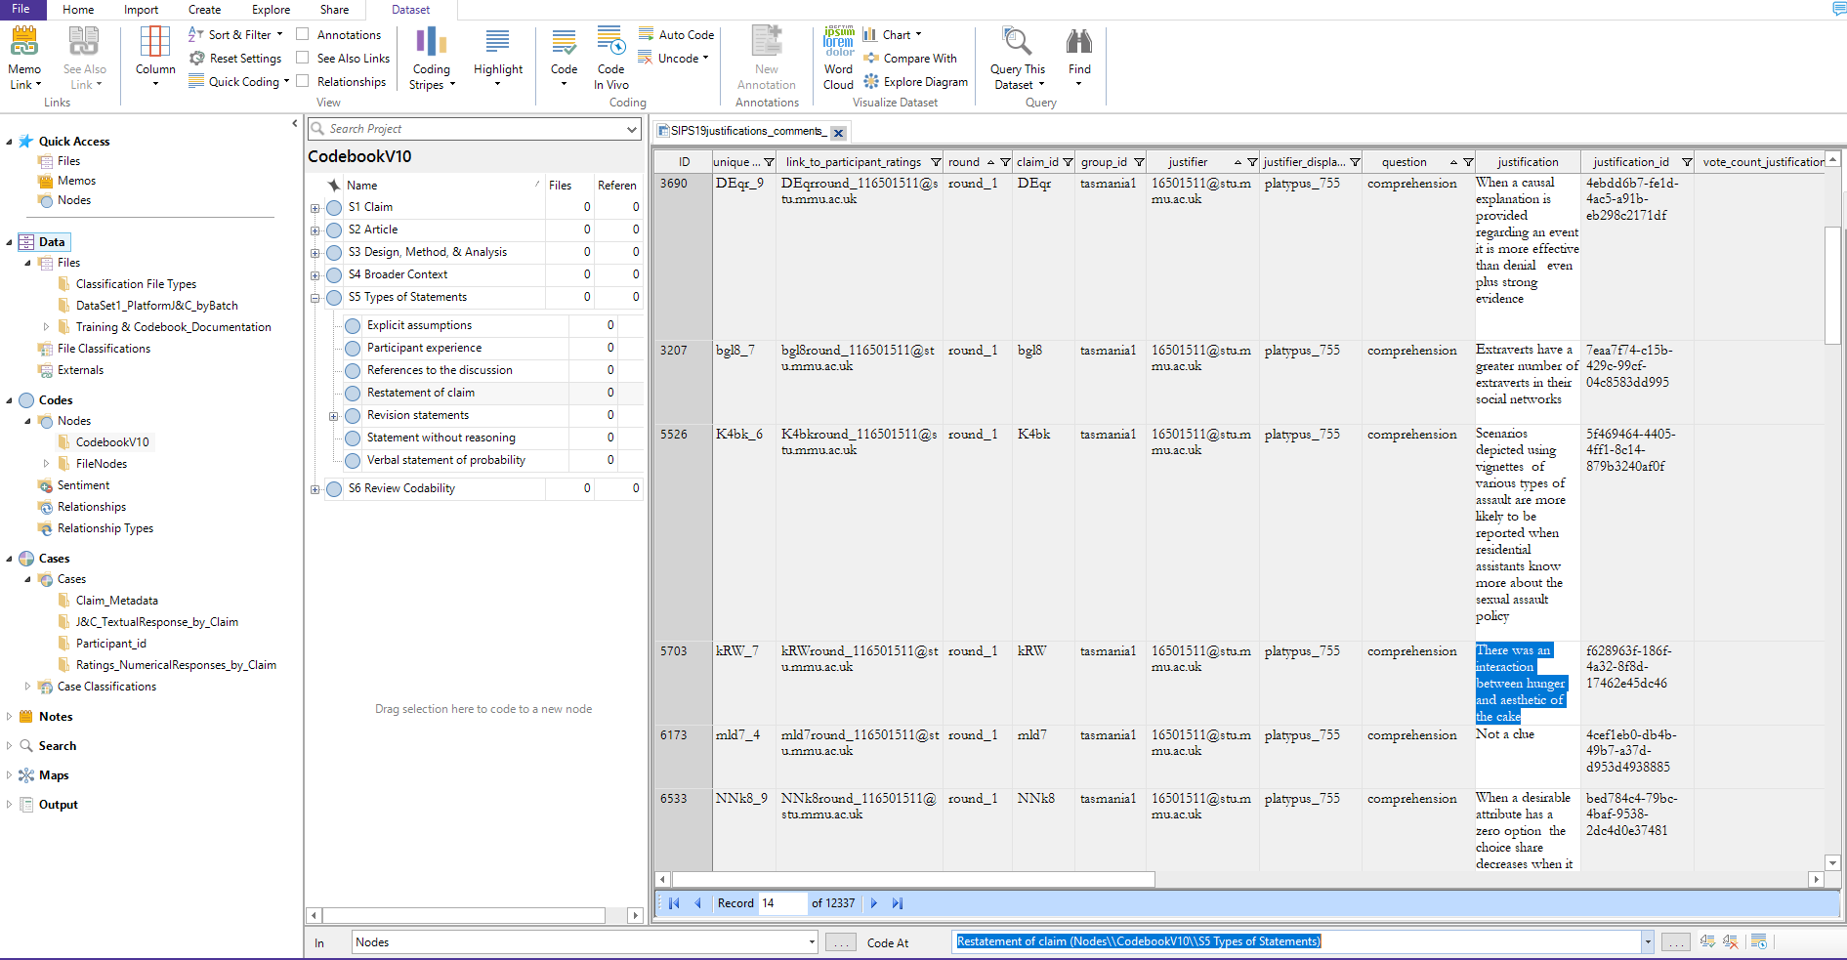

#### Assigning CASES and CLASSIFICATIONS

This is not necessary for first-round of coding, but there may be times that coding for cases may be specifically requested.

The are several approached to this. One process for coding to CASES is similar to coding for Nodes. For example, it can be done via the coding-bar once select all the text in the cell to be coded. For example,

* To link the text to the participant demographics response, search for the justifier’s email address followed by (Cases\\Participants) and apply code AND **select ‘CASES’** in the left-hand side drop-down menu (Windows) or the right-hand side of the panel (Mac).
* To link the text to the participant’s rating for that claim, search for the justifier’s email address followed by (Cases\\Ratings_ NumericalResponse_by_Claim) and apply code AND **select ‘CASES’** in the left-hand side drop-down menu of the coding bar (Windows) or the right-hand side of the coding panel (Mac).



### Further Resources:

1. A copy of the Codebook with and without layer 3 nodes is available within the NVivo project
2. A copy of the ‘Participant cheat sheet’ for context the guidance that participants were given in answering the questions on the platform. – available within the NVivo project
3. Supplementary Material: Example of how Platform Questions Look to Participants

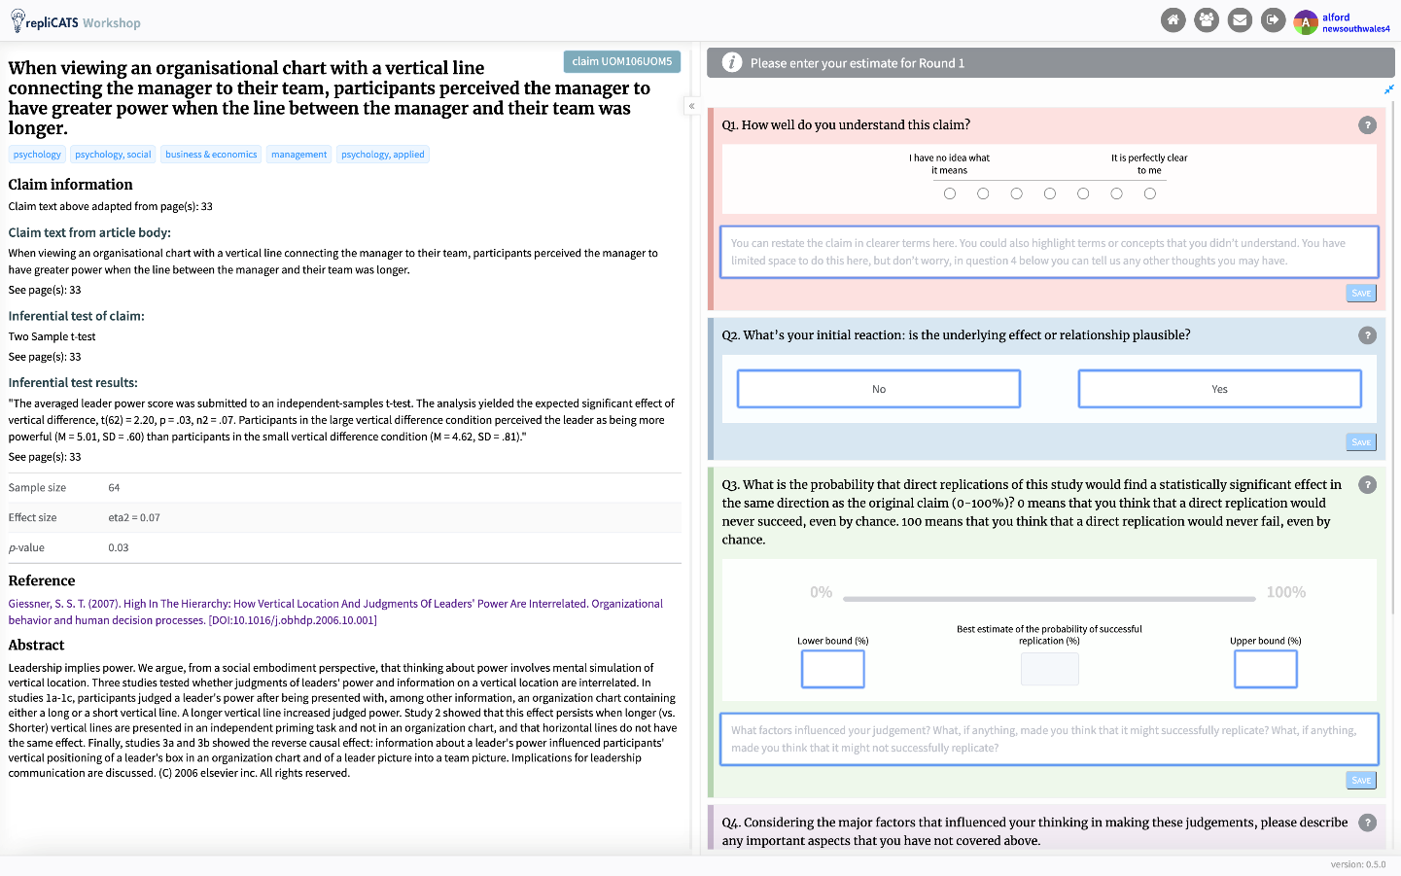

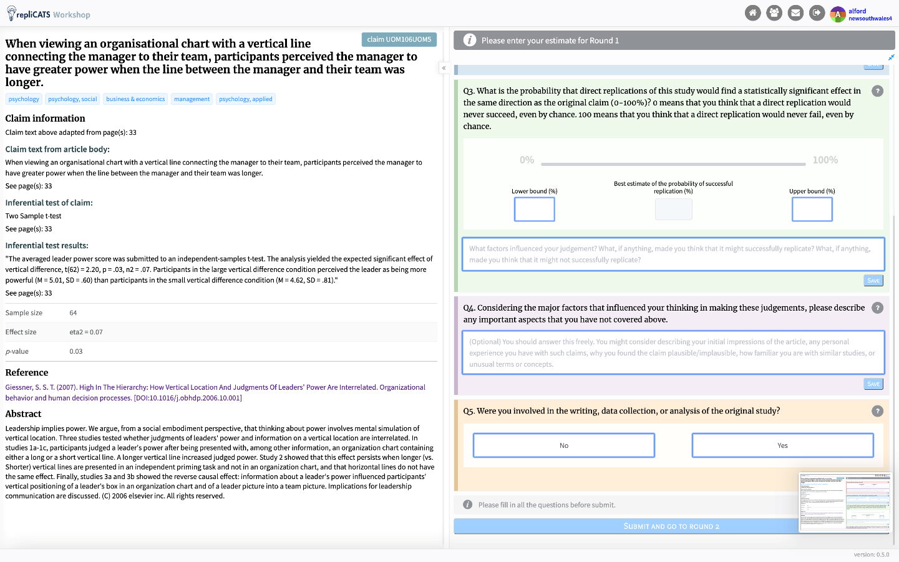

1. Note that naïve coders are sometimes referred to as ‘blind’ coders.
2. See the supplementary material, for a snapshot of an NVivo Codebook showing Layers 1, 2, and 3. (with only one of the layer1 level ‘opened up’).
3. A popular way is to use the Coding bar (Windows) or the coding Panel (Mac). The coding bar includes a drop-down menu ‘In:’ which should default to ‘Node’, and ‘Code at’: search bar that drops down into a filtered list by search. The coding panel includes a search box and a list of results filtered by the search on the left, and a list on the right-hand side where you choose ‘Node’.